North Dakota Emergency Medical Services Foundation
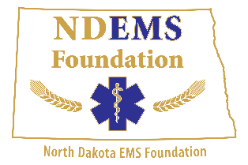
Dale Severson Memorial Golf Scramble

Sponsor Information

Sponsor Name:
Physical Address: City: State: Zip:
Mailing Address: City: State: Zip:
Contact Person: _____ Phone: EXT:
Email Address: ______
Sponsorship Levels:
Hole Sponsor: $100
Birdie: $200
Par: $500
Hole-in-One-$1000 (One free team in the scramble)
Silent Auction Item

________ YES, I would like a team in the scramble for my Hole-In-One Sponsorship

________ NO, I do not wish to have a team in the scramble for my Hole-In-One Sponsorship

________ YES, I would like to be a sponsor or donate a Silent Auction Item

Sponsorship Level: Sponsorship Amount: $______________________
** All Sponsors will be recognized with signage at the Underwood Golf Course.
Will Sponsor Provide Logo for Advertisement: YES / NO
Receipt Requested: YES / NO Send Receipt Via: Physical Address / Mailing Address / Email
Other Information:
Check made payable to: On-line Registration:
North Dakota EMS Foundation www.ndemsa.org/Foundation
1622 Interstate Avenue
Bismarck, ND 58503 Your Logo can be sent to: 701-221-0567 ndemsa.office@ndemsa.org
ndemsa.office@ndemsa.org (jpeg if possible)

For more information please contact the NDEMSA office or Mark Haugen, President at:
mshaugen@bis.midco.net
701-527-5997

Thank-You For Supporting the NDEMS Foundation!!

